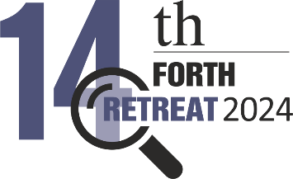
The ubiquitous need for integrating data for e-science and the data transformation framework of FORTH-ICS-ISL
Yannis Marketakis ^{1,2#*} and Yannis Tzitzikas ^{1,2*}
¹ Institute of Computer Science, FORTH-ICS, Heraklion, Greece
² Computer Science Department, University of Crete, Heraklion, Greece
# Presenting author: email: marketak@ics.forth.gr
* Corresponding authors: emails: {marketak, tzitzik}@ics.forth.gr

abstract
Data is the cornerstone of research and innovation and facilitates the integration of different computational tools and methods to address complex scientific problems. They enable researchers to collect, analyze and share vast amounts of information, driving insights across disciplines. They are described using various formats, structures and schemas and are stored and disseminated using different technologies. It is evident that there is a need of methods and tools for the management of such heterogeneous data collections. Semantic Web provides the technical backbone for achieving that through semantic data integration. Semantic data integration refers to the process of collecting and transforming data with respect to one or more commonly agreed syntax and structure, acting as a common schema, for example an ontology. This is background of the data transformation framework that was developed and evolves from the Information Systems Laboratory of FORTH-ICS. At the center of the framework there is a mapping specification language guiding the data transformation process. Through a collection of complementary services and tools, the framework supports the transformation of scientific data in a collaborative and efficient manner. It has been successfully applied to semantically integrate data for different scientific disciplines such as biodiversity, food science and cultural heritage, however it is quite generic and can be applied to other domains as well.

